RMS KEYS

Documentation

V2.0

Introduction

Overview

Many musicals from the recent past have been arranged with specific synthesizer parts in mind. To the musical director interested in an authentic performance, this can pose a number of problems. First, many of these vintage keyboards are no longer made, and therefore are difficult if not impossible to find. Second, most of these musicals use sounds that were created specifically for that show, and the descriptions in the keyboard parts may be obscure at best.

ALTAR BOYZ, for example, is orchestrated for two specific models of Korg keyboards manufactured around 2001 – the Korg Triton Pro and Korg Triton Studio. Some of the setups called for are:

Seq. Analog Hns.
Brassy Motion Synth
Hybrid Bells
Club-y Sounds

Obscure, to say the least!

Up until now, the keyboard player, in order to achieve authenticity, has been forced to listen to cast recordings and attempt to design keyboard sounds that best approximate what they hear and see notated in the score. This is an arduous process even for a seasoned keyboard programmer, and will inevitably result in setups that are less than ideal. In addition, the setups need to be ordered correctly and efficiently so that the player isn’t searching for the right sound in the middle of a rehearsal or performance.

RMS Keyboards is designed to eliminate all this work. Each show in our library has been meticulously researched, and the correct sounds have been arranged in order with an easy to use software application that supports as many keyboards as the show calls for. Simply download the software, connect your controller keyboards to the ports on the computer, hook up your audio interface, and follow the easy to use wizard installation guide.

For those who wish to evaluate the product before making a purchase decision, all our shows come with a trial version. The trial version is fully functioning for the first few songs of a given show. Thus you can be assured that what you purchase will work for your organization’s production.

Features

With RMS Keyboards, you have:

- Authentic sounds for every keyboard part within a specific show
- Individually programmed setups, in correct order
- Setup names identical to the names in the parts book
- The ability to modify names of setups and songs to reflect individual productions
- Individual panning and volume controls for every patch in the show
- Easy advance to the next setup with programmable hot keys
- Global volume control
- Built in reverb controls
- The ability to connect up to 3 midi keyboards to a single RMS Keyboards installation, with multiple audio outputs supported through your audio interface
- The ability to mute keyboard parts or setups
- An easy to read reference window showing the current setups
- 24/7 technical support

Download and Installation

Running the Trial Version

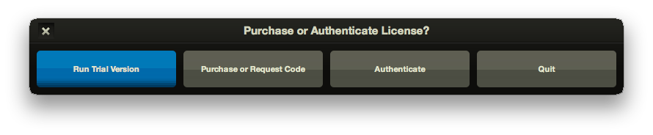
The trial version is a fully featured application that allows you to experiment with how RMS Keyboards works. This version gives you full access to the first few songs in the show. If you decide that RMS Keyboards works for you, then you will be able to purchase and authenticate the full version through the program itself, without any additional downloads.

Running the Full Version
Full versions of RMS Keyboards are only available to individuals and organizations that have acquired the license for a specific show through the appropriate licensing organization (MTI, R&H, etc). In order to purchase the unlock code for the full version, you will need to license the production through the licensing organization. The license will run for a particular length of time, depending upon the arrangement you have made with the licensing organization. At the end of your license, RMS Keyboards will notify you that your license has expired.

Purchasing the Full Version

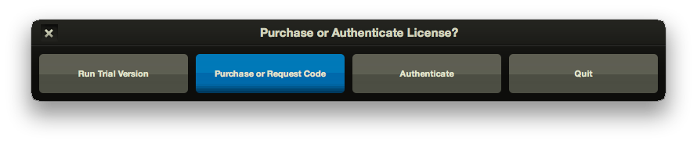
When you click on the Purchase button, you will be taken to a screen where you will be asked to fill out the appropriate information. Enter your name, organization, desired show, email address, and location. Important: if you have not already licensed the show, you will not be able to purchase the full version.

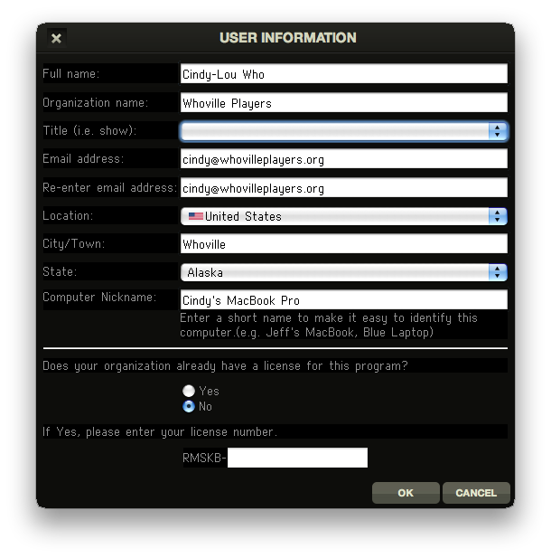

If there is an Internet connection issue, then you may receive the following screen: (insert screenshot)

If you hit “Okay”, a file will be created on your desktop called ‘rms_authentication.txt’. You can email that file to info@rms.biz from a computer with an Internet connection to continue with the purchase request.

Once RMS receives your request, we will check to make sure you have licensed the show for production. Once we have confirmed your license, we will email an electronic invoice that can be paid online through Google Checkout via credit card. We can also accept checks. Please note that we do not accept payment via purchase order.

Authentication

Once you have received you unlock code, you can authenticate the application. Press the Authenticate button on launch.
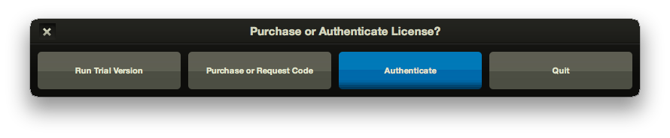
You will then be prompted to enter the unlock code from the file you received from RMS. You may copy and paste this code into the text box (CTRL-C / CTRL-V on Windows, COMMAND-C / COMMAND-V on Mac). WARNING: Make sure that you keep the unlock code in a safe place: you will need this in case you wish to reload the application or reset it to original defaults. The unlock code is machine-specific: you will not be able to load this onto a different computer.

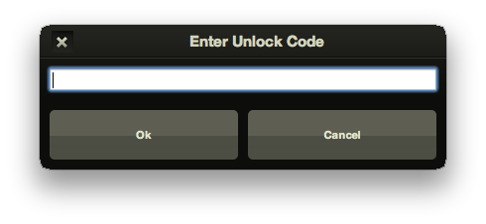
If you have entered the correct code, then you will receive a confirmation dialog box. Clicking on OK will the launch the full version of Keyboards, and each launch from this point on will bypass the original screen

Expiration of License

As mentioned above, the license for a particular show is time based. If you attempt to launch Keyboards after this period, you will be notified of this with the following dialog box:

(insert screen shot here)

If you wish to extend the length of the license, or feel that there is a mistake, then please call us at 212-620-0774 and we will be happy to assist you.

RMS Keyboards Setup
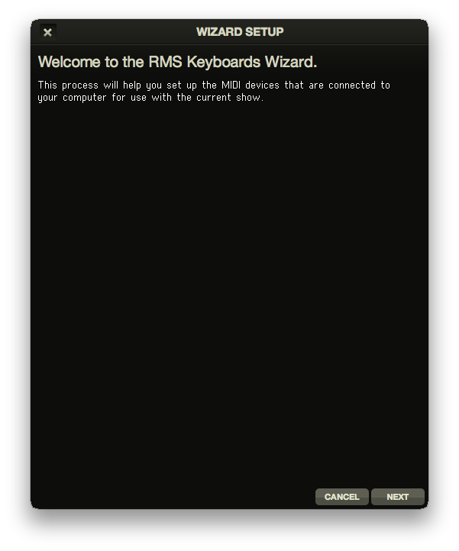
It is simple to set up RMS Keyboards. With your MIDI-enabled keyboard(s) to your computer, select ‘Run Set-up Wizard’ from the File menu. This will configure your computer for use with RMS Keyboards.

Please note, it is important that you have your MIDI keyboard(s) connected to the computer before you launch RMS Keyboards for the program to recognize your device!

Configure keyboard input - Keyboard Wizard

In live performance, RMS Keyboards is performed via connected MIDI-enabled keyboards. The specifics of how you connect your keyboard(s) is left up to you, but for suggestions on what you might need, please visit our website at www.rms.biz or visit your local music equipment retailer.
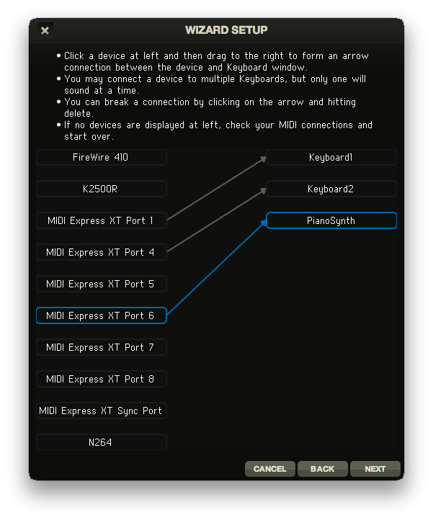
When you run the keyboard input section of the Wizard, you will see two columns of items. The left column is the list of MIDI-enabled devices connected to your machine. The right column is the list of possible “Instruments” that those devices can be connected to. These “Instruments” correspond to the published piano/synthesizer books for your selected show.

To connect a MIDI device to an instrument, simply click-and-drag to create a link. You should be aware that is possible to connect a single MIDI device to all instruments in RMS Keyboards. In that situation, only the “active” instrument (indicated by an orange border in the program window) will be triggered by your connected MIDI device.

To remove a connection, simply click on the link so that it is highlighted blue and hit “delete”.

Configure hotkey input – Keyboard Wizard

Within a single song, there are often many different sounds called for by the orchestrator. For example, in #3 Joseph’s Dreams from JOSEPH AND THE AMAZING TECHNICOLOR DREAMCOAT, the keyboard 1 player has to play harpsichord, then Hammond organ, “sharp brass”, a trumpet/trombone split and then back to “sharp brass”. Changing between these setups in RMS Keyboards is handled by way of a hotkey. Hotkeys can be assigned to any key on your MIDI device.
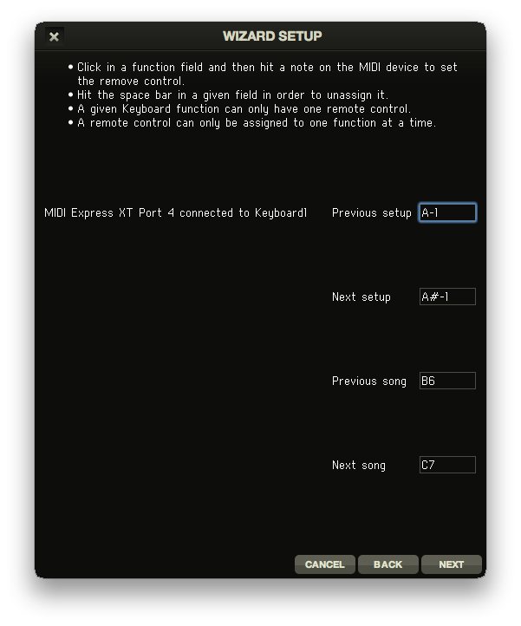
There are specific hotkeys for the following actions:

- (go to) Previous setup
- (go to) Next setup
- (go to) Previous song
- (go to) Next song

To assign hotkeys within the Wizard, click within the text field for each hotkey and press the desired key on the associated MIDI keyboard.

It is also possible to type in the desired key in the text field. For example, if you want middle ‘C’ (C3) to be assigned to ‘Next song’ (this is probably not a good idea), just click in ‘Next song’ and type ‘C3’.

With this technique, you can assign hotkey values outside the range of your playable keyboard, and then within your MIDI keyboard assign certain pedals or buttons to “play” those notes, and thus, trigger the hotkey. Not all MIDI keyboards have this capability however, and you should check your documentation.

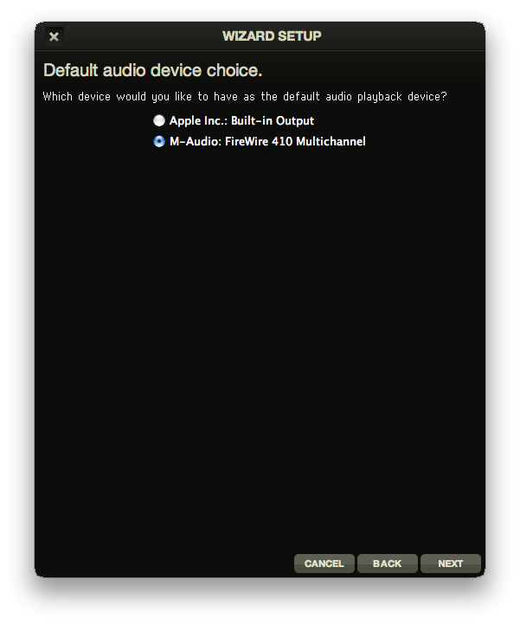

Configure audio output

The final screen of the Wizard selects which audio device you want RMS Keyboards to run through. For example, if you have an M-Audio FireWire 410 connected to your computer you would select that on the following screen.

It is possible to run sound out of your computer’s default audio device (i.e. the headphone jack on a laptop) but you will have fewer options on routing the sound, as well as decreased quality of sound when compared to an external audio device. For suggestions on what hardware you might need to route your audio, please go to www.rms.biz or visit your local music equipment retailer.

The RMS Keyboards Interface

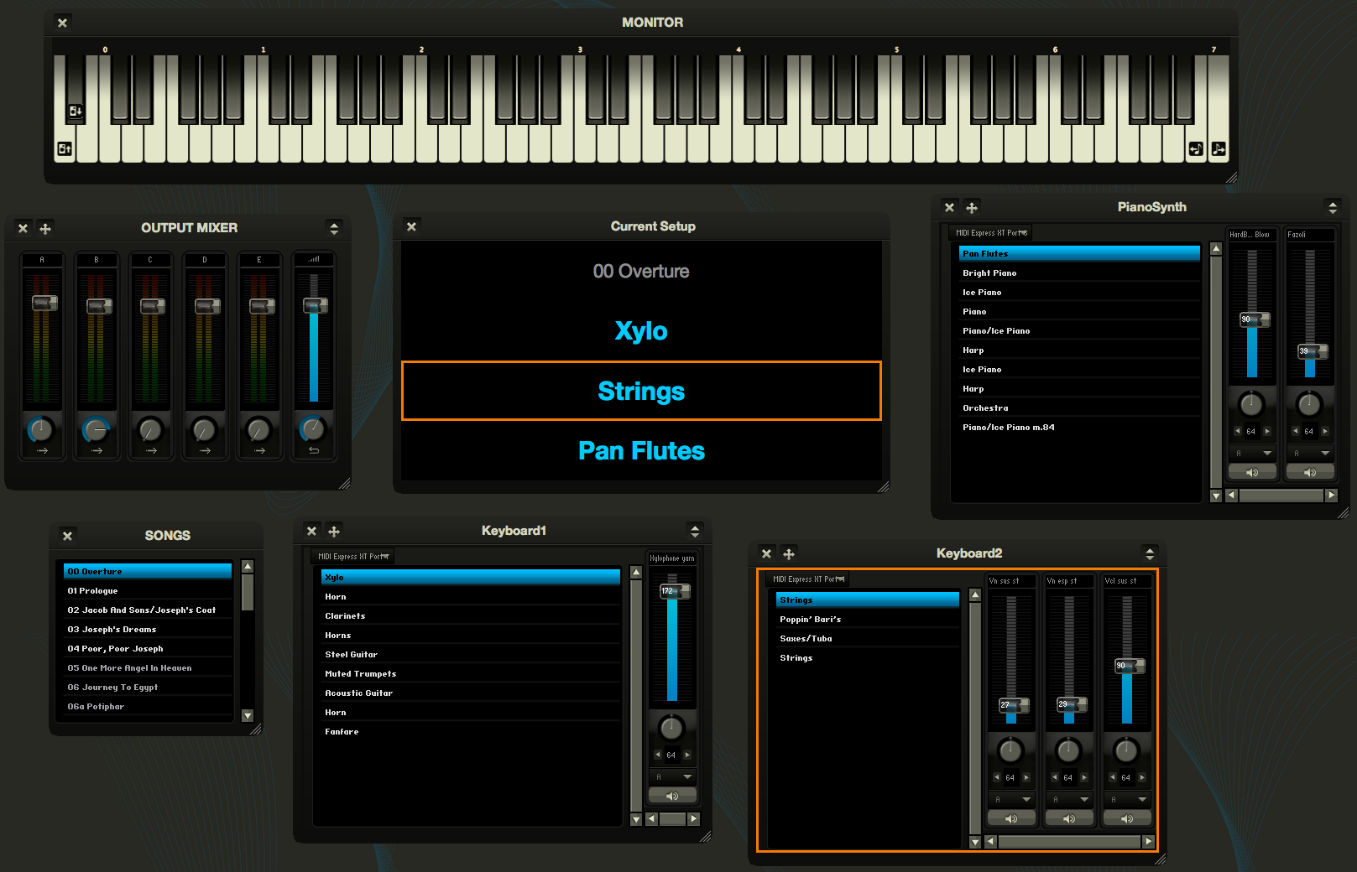
a typical RMS Keyboards setup

The Monitor Window

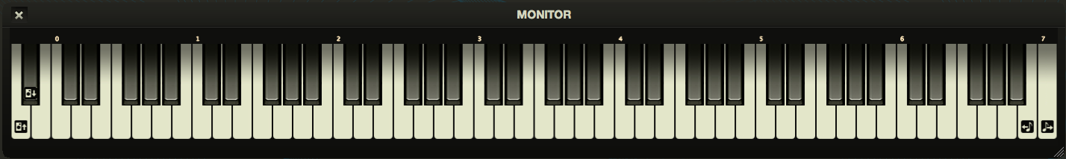

The Monitor window is a basic representation of a keyboard, and will show MIDI data for the active keyboard as the program receives it. In addition, it shows icons for the hotkey assignments within the range of a typical 88-key controller.

Previous setup | Next setup | Previous song | Next song

The Songs Window
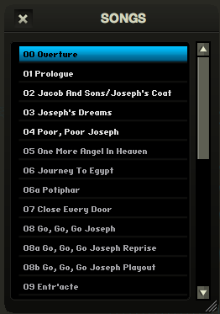
This is a list of all the songs for the currently installed show. You can click on a song name to jump to that song within RMS Keyboards. If you wish to rename a song, simply double-click on the name of the song and type in the new name.

Please note, it is not currently possible to change the order of the songs in RMS Keyboards, or to delete songs from the list. If your production is not performing the standard order for a given show, you will need to jump to the appropriate song via hotkey or by clicking in this window.

In addition to using hotkeys to switch songs, you may also use the ‘right arrow’ and ‘left arrow’ keys to switch the currently loaded song.

RMS Keyboards loads groups of setups organized by song. Because of this, it is not possible to have Keyboard 1 playing a setup from ’00 Overture’ and Keyboard 2 playing a setup from ’01 Prologue’ at the same time. All instruments load from the same song at the same time, and switching songs will switch available setups to all instruments.

The Instrument Window
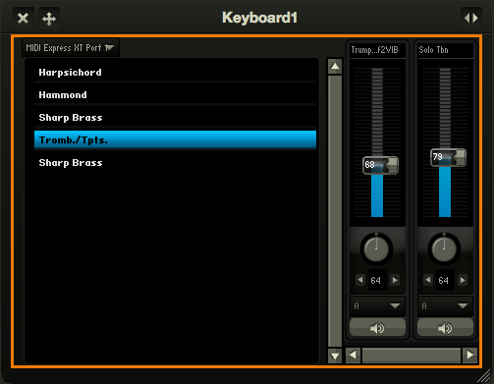
A single RMS Keyboards installation will have as many different ‘instruments’ as there are keyboard books for that show. For example, JOSEPH calls for Keyboard 1, Keyboard 2 and PianoSynth. ALTAR BOYZ calls for Piano-Conductor and Keyboard 2.

Only one instrument may be active at any given time. The active instrument will have an orange border around it, as seen here. The active instrument will have its MIDI input and hotkeys mirrored in the Monitor window, and will be the instrument that is played by a MIDI controller connected to multiple receiving instruments.

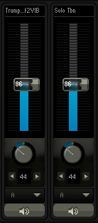
The left pane of the instrument window will show the list of ‘setups’ called for by the current song, in the order that they appear in the score. Each setup will have a name that closely resembles the name in the score, though you may change the name to something more to your liking by double clicking on it. You can advance through setups by use of the Next/Previous Setup hotkeys or by the up/down arrow keys on the computer (for the active Instrument). If you have the “Cycle through songs” option selected under “Preferences”, hitting ‘Next/Previous Setup’ will automatically change songs when you get to the last (or first) setup in a list.

The right pane of the instrument window shows channel strips for each “patch” within a specific setup. Each patch has its own volume slider, L-R panning knob, output channel selector and mute/unmute button.

The volume sliders have a range of 0-200, and the panning knobs have a range of 0-127, with ‘63’ being center.

Changes made in these channel strips apply to the current setup only! To make global edits to the instrument, you will need to activate the Global Edit toggle in the upper left of the instrument window.

Global Edits in the Instrument Window

Global Edits – inactive | Global Edits - active

Toggling the Global Edit icon will allow you to make sweeping changes to all setups within the current instrument. Use this for:

- Setting an entire instrument to route through a different channel in the Output Mixer. (This is useful for external mixing of multiple instruments with your audio hardware)
- Adjusting the volume or panning of an entire instrument.

Please note that changing the volume or panning while in Global Edit mode is absolute, not relative. Setting the volume slider to “60” will change the volume of every patch in every setup for that instrument to “60”, and thus, overwrite any subtle mixing of patches that you might have done.

To protect you from accidental global changes, you will be presented with the following screen the first time you change a specific parameter while in Global Edit mode:

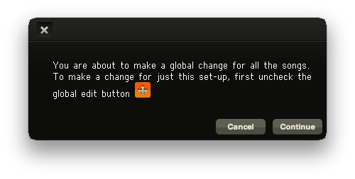
If you wish to leave Global Edit mode, simply hit ‘Cancel’ and uncheck the Global Edit button.

The Edit Drawer in the Instrument Window

Each instrument also has an Edit Drawer (closed by default). To open the Edit Drawer, click the icon in the upper right of the Instrument Window.
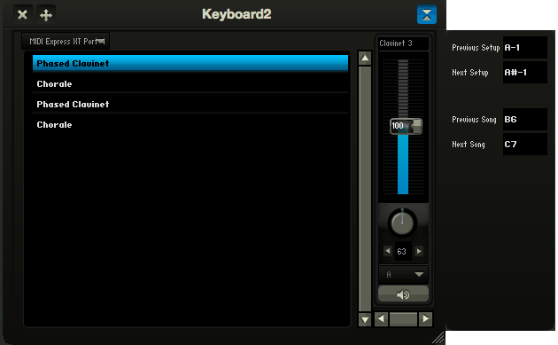
Within this drawer, we see fields displaying the hotkey assignments for Previous/Next Setup and Previous/Next Song. You can change these hotkeys here by clicking on the field and playing the desired note on the keyboard, or by typing the value into the field. Once finished, you can close the drawer by clicking again on the drawer icon.

The Output Mixer
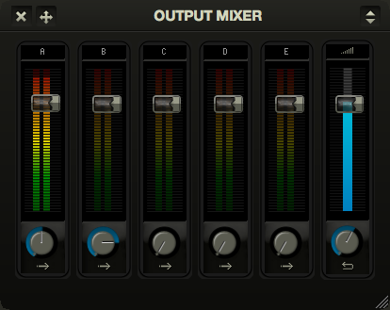
The Output Mixer allows you to make adjustments to the volume of instruments routed to specific channels, as well as the level of reverb assigned to each channel. These settings are saved per song, allowing you to tweak volume levels and reverb settings on a song-by-song basis.

These settings are not global by default. Adjustments made to these faders and knobs apply to the current song only, unless you are in Global Change mode.

Ports A-E each have a separate volume fader, as well as a ‘reverb send’ knob. To the far right is a blue ‘global volume’ fader and a ‘reverb return’ knob. ‘Reverb send’ determines how much of the signal passing through a specific channel gets sent to the reverb engine, and ‘reverb return’ determines the overall level of reverb present in the mix.

A note about reverb: to keep the CPU requirements of RMS Keyboards low, we only allow reverb to return on a single port. You can specify which port reverb returns on within the Edit Drawer of the Output Mixer, as detailed below. Keep in mind that you can always add your own external FX processing, including reverb.

By default, every setup in every instrument defaults to port A, which corresponds to the main output on your external audio device. RMS Keyboards gives you a lot of control over how you route your audio. If you want to send all of Keyboard 1 to port A, all of Keyboard 2 to port B, and so forth, you can do that! If, instead, you would like to send all “string” sounding patches to A (with a lot of reverb), all “piano” patches to B (with light reverb), and everything else to C (with no reverb), you can do that too! RMS Keyboards gives you more ways to control your mix than most standard synthesizers.

Above the channel strips are drop down menus allowing you to quickly change the audio device and buffer size, without having to run the Setup Wizard again.

Global Changes in the Output Mixer

By activating the ‘global edit’ icon on the Output Mixer, you can adjust the volume faders and reverb settings for every song in the show. You will receive a warning screen on first adjustment to prevent any accidental changes while in Global Edit mode.

Please note that changing the volume or reverb settings while in Global Edit mode is absolute, not relative. Setting the volume slider to “60” in Global Edit mode will change the volume of that port for every song to “60”.

The Edit Drawer in the Output Mixer
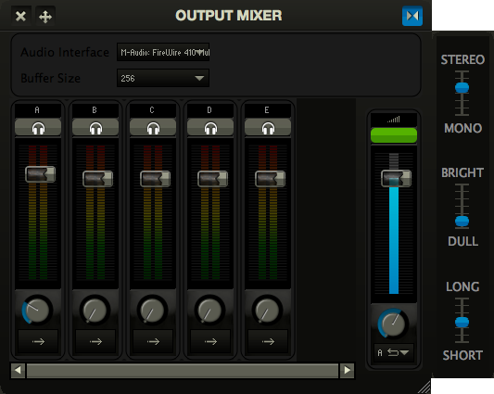
Clicking on the Edit Drawer icon in the upper right of the Output Mixer will allow you to tweak reverb settings. You can reverb width (mono vs. stereo), brightness (bright vs. dull) and length (long vs. short). Experiment with these settings to find a sound that suits you and your performance space. And as a reminder, edits made to these reverb settings are on a song-by-song basis, unless you are in Global Edit mode.

While the Edit Drawer is open, you will also see a button above each channel strip with an icon of headphones on it. Clicking on these buttons will toggle a sine wave “test signal” to that specific port. This will allow you to check the audio routing of your external audio device without having someone play RMS Keyboards constantly. You should use this feature as part of your daily pre-show sound check to prevent unwanted surprises come performance time!

The small green window above the master fader will show you the maximum number of voices that have been triggered at any given time. RMS Keyboards has a limit of 128 voices, and going over that number will cause the window to turn red. Clicking on that window will reset the counter to 0. Don’t worry; it would take very bombastic performances by many pianists to play 128 notes at once!

The Current Setup Window
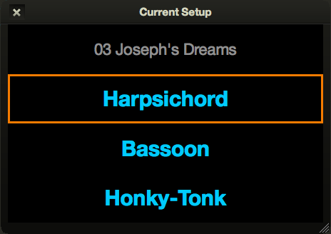
One of the unique challenges of using RMS Keyboards in performance is being able to quickly reference what setup you are currently playing. Programmable synthesizers made by companies like Korg and Roland have digital readouts displaying the name of the current setup in an easily readable location. To give the same sort of ability to RMS Keyboards, we have added a window showing the current song and setups for every instrument in a given show. Space in pits is often at a premium, and this feature allows you to set the laptop off to the side or a few feet away while still giving you the most important information in an easily readable format, even at a distance.

The order that the setups appear in, top to bottom, will match the order of the keyboard books in the orchestration; for example, Keyboard 1/Keyboard 2/Pianosynth or Piano-conductor/Keyboard 2. The currently active instrument will have an orange border. If you click on the name of any instrument it will make that instrument active and bring the instrument window to the foreground, even if it is hidden. Is your partially deaf Keyboard 3 player on “SFZ Tuba” instead of “Sweet Strings”? Click on the setup name and change it for him/her!

Operation

Playing

Once RMS Keyboards has been configured, launching the program will automatically activate your system and playing is enabled. Simply press the keys on your connected keyboard or keyboards and the currently selected setup will play the correct sounds out of your computer. At this point, you are basically ready to perform the show!

Navigating through the show

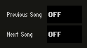
As we discussed above, groups of setups are organized per song, and only a single song may be active at any given time. Each player is responsible for advancing their setups as indicated in the score, but every player also has the ability to advance the song! You can imagine the problems that might occur if both Keyboard 1 and Keyboard 2 hit a hotkey advancing the song at the same time. All of a sudden, you are in “08 Fight (With Explosions)” instead of “07 Romantic Ballad”! For this reason, it is a good idea to designate a single person to advance the song via hotkey, and to disable the Next/Previous Song hotkeys in the other instruments. To do this, open the Edit Drawer for those instruments, select the values in the Next Song and Previous Song fields, and delete them.

In addition to controlling the current song/setup by MIDI hotkey, you can also use the arrow keys on the computer keyboard to navigate. The up and down arrows will change the current setup for the active keyboard, and the left and right arrows will change the current song. You can also use the mouse to jump to any song or setup.

Adjusting Volume in Performance

Every installation of RMS Keyboards comes carefully pre-mixed for an excellent sounding configuration right out of the box. In addition, you have the ability to tweak and fine-tune the mix ahead of time. The ability to quickly adjust the overall volume in a performance setting will ultimately be decided by your specific audio setup. There is probably going to be a keyboard amp or other mixer in your setup where you (or your audio technician) can quickly make adjustments.

To ensure that you have a good general volume to work with, however, we recommend going through the following steps:

- Plug in and turn on RMS Keyboards and your external sound system
- Test to make sure you are hearing sounds
- Select a suitable loud sound from RMS Keyboards, and without making any volume adjustments in RMS Keyboards, set the output volume on the external sound system to an appropriate level. If there are VU meters in your setup, then you should see a nice reading without it clipping (hitting the peak value, or “going into the red”)
- Once you are certain you have a good default value, mark it with tape or some other means so you know where to set it

Adjusting the Global Volume via MIDI

As an alternative, it is possible to use MIDI to control the Global Volume level, found on the far right of the Output Mixer window. This adjusts the overall volume of ALL audio outputs, and is universal to the entire show, so if you make an adjustment, it remains as you navigate through songs and setups (this functionality is broken as of r2449 – DH).

If you have an MIDI controller that can send volume control data (MIDI CC 7), that can be used to adjust the global volume within RMS Keyboards. Simply set whichever knob or fader (or volume pedal) to send a “volume” control command, and you have to ability to adjust the volume on your MIDI controller itself. (This needs to be tested/implemented – DH)

Menu Commands

File

Save
Saves the current window configuration as well as any volume changes, reverb settings, hot key commands, and any other modifications to the default setup.

Windows
Show or hide any of the component windows in RMS Keyboards.

Tools

Panic
Send an “all notes off” command to RMS Keyboards, in the case of any notes getting stuck for whatever reason.

Run Set-up Wizard
Launches the configuration utility to assist you with routing MIDI devices, setting hotkeys, and choosing an audio output device.

Run SampleSync
Launches the RMS SampleSync, which will update your sample library with the most recent version.

Preferences
(This is going into a separate menu item, so documentation will be drafted once that occurs - DH)

Help

Turn Tooltips Off
Disables tooltips in RMS Keyboards (should this go under Preferences? – DH)

Purchase or Authenticate Full Version
Launches the start-up screen where you can either Purchase a license for RMS Keyboards, or authenticate an already-purchased installation.

